


AWAYDAY
Royal Leamington Spa
Saturday 12th September 2026
11.00am – 4.00pm
Warwickshire Trefoil Guild invite Trefoil members from across the Midlands Region to join them to meet with friends at our central venue to try a variety of fun indoor activities linked to the local area and enjoy a cream tea with opportunities for those wanting to explore Royal Leamington Spa, visit Jephson Gardens, find out about the Royal Pump rooms or follow a treasure trail.
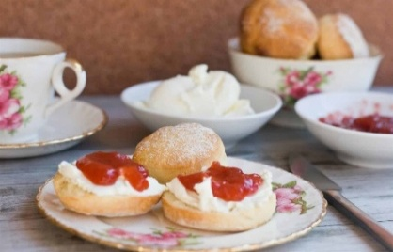

Venue: Dale Street Methodist Church, Leamington Spa
Cost £10
Bookings open 1st April & will be done through your County
Bring a packed lunch or eat at one of the many restaurants/ coffee shops

