Annual Report

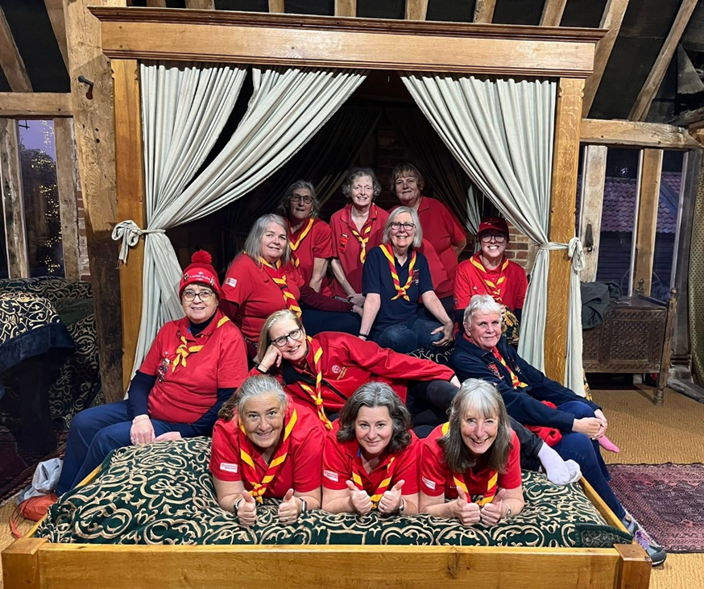
2025

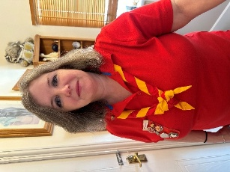
Chair’s Report – Karen Batten
This is my second report as Anglia Chair.

As always it has been a busy, fun packed year filled with challenges, new experiences, laughter, and lots of food – what Trefoil does best. Guilds continue to provide a varied and active programme for their members as well as supporting local charities and Girlguiding in their area.

We have welcomed four new guilds into the region, two in Hertfordshire and one each in Cambridgeshire West and Suffolk. ‘Lones’ guilds are starting to take shape for members who wish to remain part of the Trefoil family but cannot commit to regular meetings due to work or health reasons.
Membership has grown slightly since last year and we currently have 2576 members in the region, the second largest in the country.

Unfortunately, we also lost several members throughout the year, and they will be remembered in our hearts and prayers.

One of my favourite parts of the role is getting to meet Trefoil members around the region. I have been delighted to be invited by several counties to their Annual Review. It is great to hear about all the exciting things members have been doing throughout the year and their plans for the future.

In April we held the Anglia Annual Review in Leighton Buzzard, a big well done to Chrissy Hayward and her team for all their hard work in hosting the event. Members enjoyed a variety of activities including a train ride on the Trefoil Guild Express!

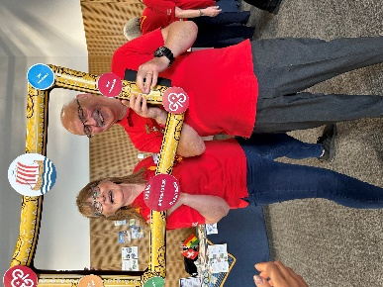
Several members from the region attended the National Annual Meeting in Belfast in June. The Anglia stand included a boat race which proved to be a great hit with members, one of the more competitive being the Chief Guide Tracey Foster.
There was also an inspirational guest speaker, Clodagh Dunlop who gave a very moving account of her experience with ‘Locked in’ syndrome.

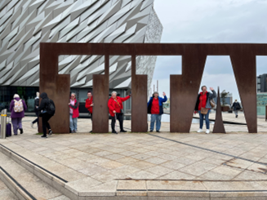
Many members took advantage of having a short break in Belfast and visited lots of attractions including the amazing Titanic exhibition and the Crumlin Road Jail.
International at Home has been well received with many Guilds taking part, organising trips out and trying new foods and activities. Some counties are including this as a theme for their County Days.
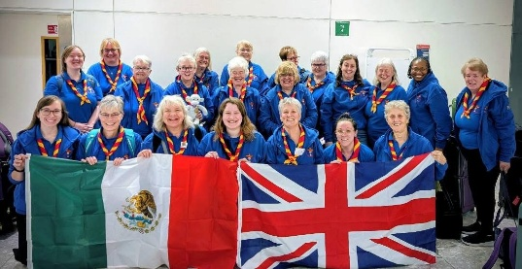
Several members went on an Anglia trip to Our Chalet and others went further afield to Nuestra Cabana to celebrate ‘The Day of the Dead.’

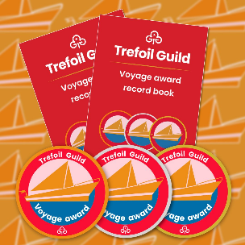
Voyage continues to be popular in Anglia with twenty-one Bronze, five Silver and nine Gold being awarded in 2025.
Congratulations to the following members for completing their Gold Voyage Award:
Angie Cable, Christine Strike, Elizabeth Jowers, and June Freeman, from Suffolk.
Kate Groves and Carol Dyson, from Bedfordshire
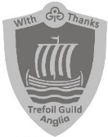
Angela Morfett-Jones, Lincolnshire S, Ann Woolley, Essex SE and Ann Byrne, Norfolk.

Eight members from around the region have been presented with the Anglia Thanks Award for going above and beyond in Trefoil Guild.
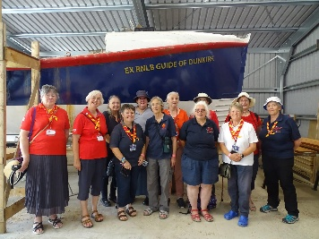
The Heraldry guild is proving to be quite popular, there are currently sixteen members, with new members joining from all over the country. One of their visits was to Abbey Boatyard in Norfolk to see the lifeboat ‘Guide of Dunkirk’ which was bought by guides in ‘Gift week‘ in 1940 and it’s first voyage was to Dunkirk to help in the rescue of the troops.
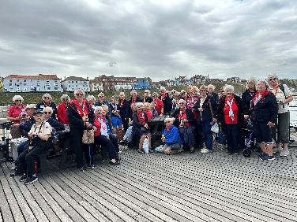
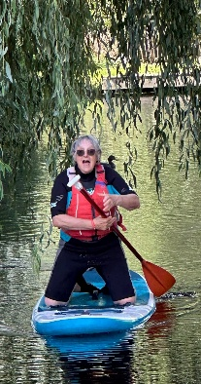
The annual Anglia holiday was held at Hautbois and had a seaside theme, the group enjoyed a lovely afternoon at the end of the pier show in Cromer. Some members were quite adventurous and took to the water on paddle boards, reports afterwards said that the water was quite chilly!
Links with Girlguiding continue to grow, and I would like to give a special shout out to Trefoil members who have answered calls to assist with Girlguiding activities and large events throughout Anglia, your help is greatly appreciated.

The activities that members take part in never cease to surprise. What other organisation can say that their members went camping, canal barging, abseiling or ran a marathon. Also, tried jewellery making, Tai Chi, bushcraft, crazy golf, silk screen printing, pottery and much more. There were visits to breweries, old churches, museums, theatres – I could go on ……..

I look forward to continuing my travels around the region, meeting members, and taking part in some of the exciting activities. Don’t forget to invite me!

Finally, in bringing this report to a close can I thank the Anglia Team – the County Chairs, Advisors, Treasurer and the Secretary for their support and the work they do across the Region.

However, the biggest thank you must go to all Trefoil members, without your willingness to attend, to support your guild locally and county wide this would not be possible.
Thank you one and all.
Around the Region in 2025
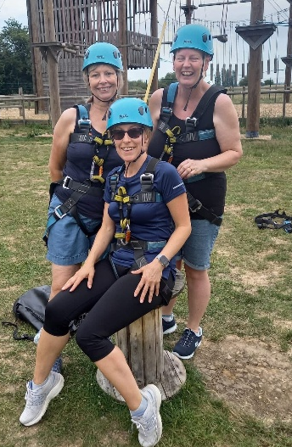
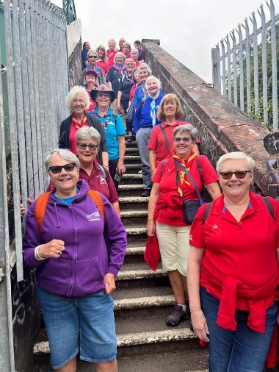
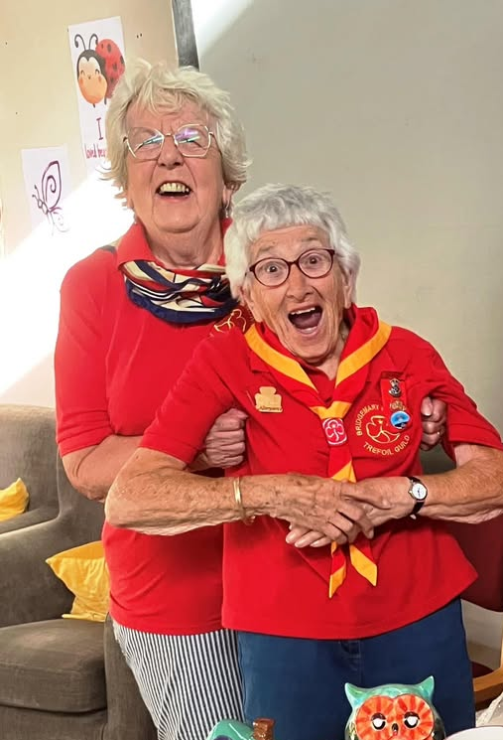
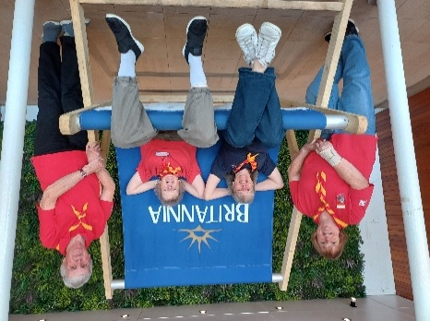
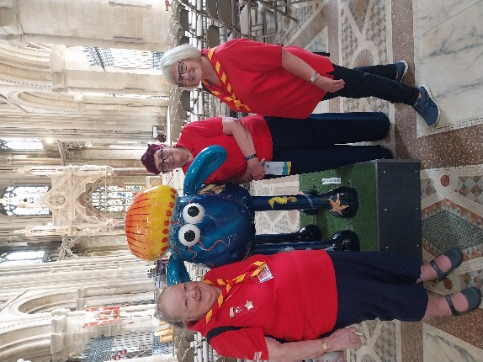

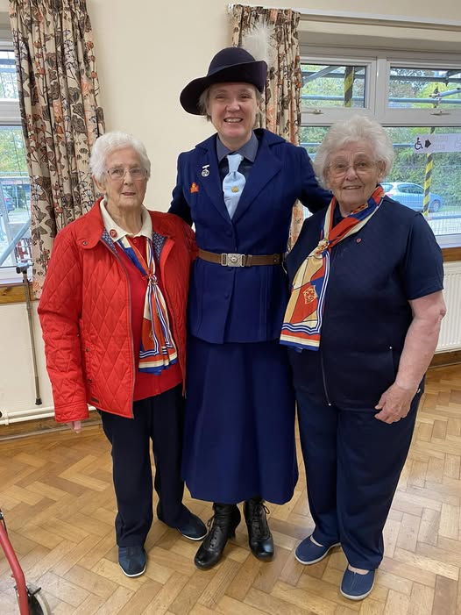

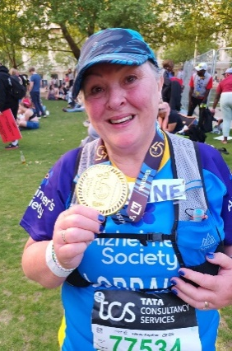

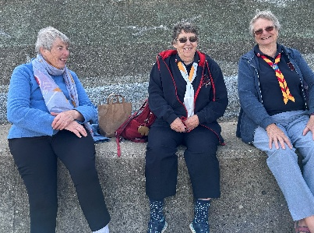
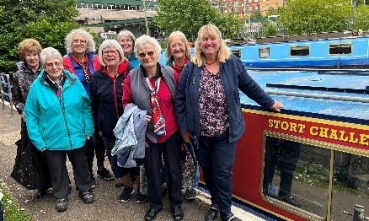

Finances – as at 31st December 2025, the total funds available to Anglia stood at £26285.62, these funds will be used to support counties and advisors in Anglia in the promotion of the Trefoil Guild and by enhancing members’ services.

