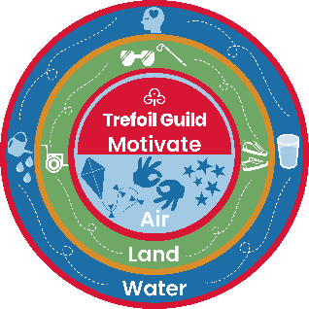  
Motivate challenge personal record sheet

This record is for the individual member and does not need to  
be presented to gain the badge.

|  |  |  |  |  |  |
| --- | --- | --- | --- | --- | --- |
| Your name | |  | Your Trefoil |  | |
| Challenge | | | Which key messages are covered? | | Tick |
| **Air** | | | | | |
| 1 |  | |  | |  |
| 2 |  | |  | |  |
| **Land** | | | | | |
| 1 |  | |  | |  |
| 2 |  | |  | |  |
| **Water** | | | | | |
| 1 |  | |  | |  |
| 2 |  | |  | |  |

Our key messages are: find friendship, get involved, get active, and give support. There is no time scale to complete this challenge. Good luck and enjoy!